Factor Plot explanation:

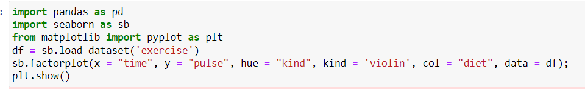

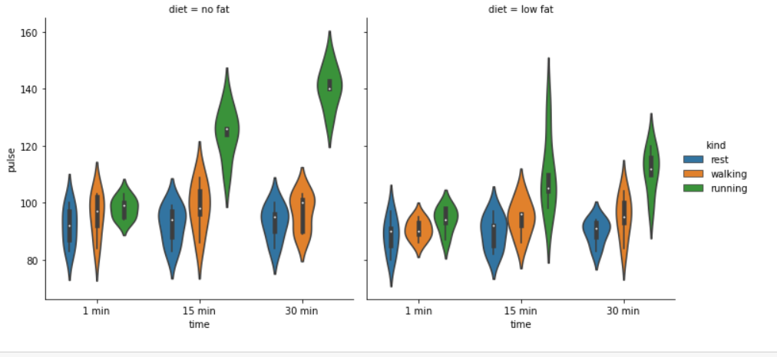

* Factor plot is gonna be talks about the exercise during diet plan some of them have no fat by the other hands some of them having low fat ,the fat is calculated by their rest , walking , running times. Here, x- axis tells the time nd y- axis tells the pulse .
* As I told fat is calculated in different kind like during their rest period , walking period, and running periods.

1. **We calculate for persons with no fat.**

* **Pulse rate calculated for 1min**
* During 1min @ rest period the pulse rates from 70 – 110, avg rate is about 80 – 100.
* During 1min @ walking period the pulse rates from 70 – 115, avg rate is about 90 – 105.
* During 1min @ running period the pulse rates from 90 – 105, avg rate is about 90 – 100.

* **Pulse rate calculated for 15min**
* During 15min @ rest period the pulse rates from 75 – 105, avg rate is about 80 – 90.
* During 15min @ walking period the pulse rates from 75 – 120, avg rate is about 90 – 110.
* During 15min @ running period the pulse rates from 95 – 150, avg rate is about 120– 130.

* **Pulse rate calculated for 30min**
* During 30min @ rest period the pulse rates from 75 – 100, avg rate is about 85 – 100.
* During 30min @ walking period the pulse rates from 80 – 110, avg rate is about 90 – 105.
* During 30min @ running period the pulse rates from 120 – 160, avg rate is about 130 – 145.

1. **Here We calculate for persons with Low fat.**

* **Pulse rate calculated for 1min**
* During 1min @ rest period the pulse rates from 75– 105, avg rate is about 85 – 95.
* During 1min @ walking period the pulse rates from 85 – 100, avg rate is about 95 – 95.
* During 1min @ running period the pulse rates from 80 – 110, avg rate is about 90 – 100.
* **Pulse rate calculated for 15min**
* During 15min @ rest period the pulse rates from 75 – 110, avg rate is about 80 – 90.
* During 15min @ walking period the pulse rates from 80 – 115, avg rate is about 85 – 100.
* During 15min @ running period the pulse rates from 80 – 130, avg rate is about 90– 110.
* **Pulse rate calculated for 30min**
* During 30min @ rest period the pulse rates from 80 – 100, avg rate is about 85 – 90.
* During 30min @ walking period the pulse rates from 80 – 115, avg rate is about 90 – 105.
* During 30min @ running period the pulse rates from 90 – 110, avg rate is about 110 – 120.
* At 30min with no fat has pulse about 150.
* At 30min with low fat has pulse about 130.